Sakura Alley

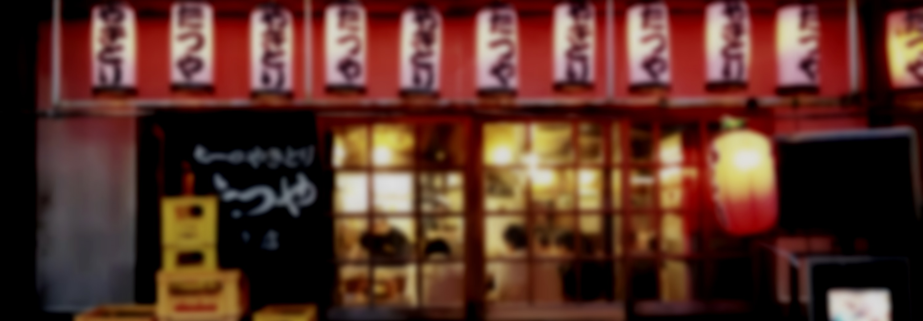

Menu

Desserts, dinner, sidedishes, drinks

Version 2016

Drinks  
  
Non-alcoholic

Cola

Fanta

Sprite

Oolong

Carbonated Water

Beers

Heiniken

Sculpin Ipa

Guiness  
Sierra Nevada

Wines

Castello di Brolio

Wester Vin

Chateau Musar

Drinks

Martines

Manhattan

Margarita

French 75

Sidedishes  
  
Salads

Green bean salad

Salad with mozzarella

Scandinavian salad

Meats

Grilled ham

Spareribs

Lampchops

Burger

From Ocean

Shrimp cocktail

Oyster

Squid

Salmon

scallops

Fried

shrimp

potato chips

chicken

Main dishes

Vegetarian

Rösti casserole with Baked eggs

Roasted Asparagus with Penne, salad and cheese

White bean soup

Fontal Polenta with Mushroom Sauté

Meat dishes

Lamb chops with fries and garlic butter

Braised Pork with Cherry Gravy

Chicken-fried steak with Redeye Curry Gravy

Parmesan and Herb-Crusted Beef Tenderloin

Meatballs with Potato and brown sauce

Bourbon Chicken

Lasagna

Salisbury Steak

Fish dishes

Pan-fried Flounder with Poblano-Corn Relish

Swordfish Tagine

Snapper in Chile-Lime sauce

Trout with Ham and cider

Sloe Gin Gravlax

Tuna & Caper butter

Desserts

Ice Creams

Blueberry

Chocolate

Vanilla

Polka

Mint and chocolate

Strawberry

Coffee

Cakes

Tiger cake

Citrus cake

Banana-caramel cake

Sponge cake with Chocolate Frosting

Carrot Cake

Red velvet Cake